Results of questionaire about bullying and cyberbullying at Primary School Bystričany, Mirka Nešpora 12/1, Bystričany 972 45, Slovakia
Bullying and Cyberbullying at school
This questionaire was done in May 2021 after the occurance of bullying at school. In order to know how the students cope with the situation, how much they know and how safe they feel at school, we did this questionaire with each class.
In this case of bullying the student was physically attacked by a student from another class and some other students were making a video from the fight. The bullying didn't happen at school or during the time the victim was at school, but on the way home. The parents notified the classroom teacher of the victim. The teacher informed the headmaster and they started questioning and investigating the case.
They had conversation with the victim and his parents and also with the aggressor and his parent. The student who had made and posted the video and witnesses were questioned, too.
The results were that the bullying happened the way that the victim desciŕibed. There were given official warnings and rebukes from the Headmaster of our school to the aggressor and the students that made and posted the video. The conseuences of this dangerous and non-social behaviour were explained to the aggressors and parents. As well, the parent of aggressor was notified about the consequences if the bullying situation appears again. The aggressor and the student had to apology to the victim in front of all involved parents.
To prevent other bullying acts at our school, we organised the discussion with the representative of Municipal Police Department who deals with the bullying prevention. Beside that every class teacher had the discussion with his/her students about the bullying, cyberbullying and prevention of these two topics.

Question 1 53 answers
I am a boy/girl.
boys | 31
girls | 22
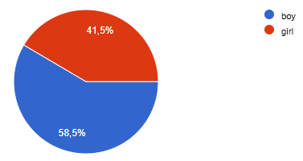

Question 2 53 answers
My experience with bullying at school
 | all | % | boys | girls
I am bullied | 0 | 0 | 0 | 0
I am cyberbullied | 1 | 1,8 | 0 | 1
I was bullied, but it has already stopped | 8 | 15,1 | 3 | 5
I was a victim of cyberbullying, but it has already stopped | 2 | 3,7 | 1 | 1
I witnessed bullying | 11 | 20,8 | 7 | 4
I watched the manifestation of cyberbullying | 0 | 0 | 0 | 0
I heard about bullying at school, I have information from social sites | 12 | 24,5 | 7 | 5
I took part in bullying | 2 | 3,7 | 0 | 2
I don't know about bullying and cyberbullying at school | 16 | 30,2 | 12 | 4

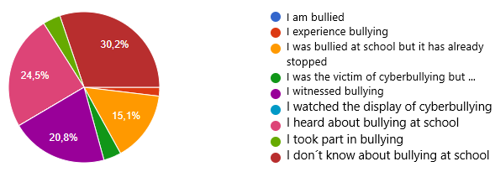

Question 3 37 answers
If you experienced or had information about bullying at school, who did you talk to about it?
 | all | % | boys | girls
classmate | 9 | 18,9 | 2 | 7
Friend, not at school | 8 | 21,6 | 3 | 5
siblings | 4 | 10,8 | 3 | 1
parents | 17 | 45,9 | 9 | 8
teachers | 9 | 24,3 | 4 | 5
Other adult | 3 | 8,1 | 2 | 1
I wrote it on social network | 0
I contacted other help | 0
nobody | 13 | 35,1 | 8 | 5

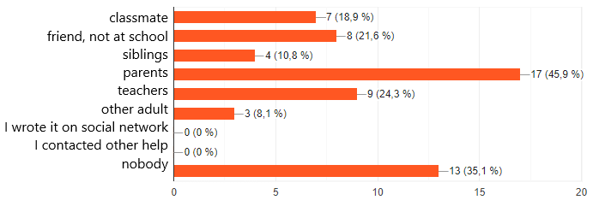

Question 4 37 answers
If you knew about bullying or you are the victim and you didn't tell anybody, what was the reason of your silence?
 | all | % | boys | girls
I was afraid of revenge |  | 16,2 | 1 | 5
I didn't believe somebody could help me | 0
I was afraid that I will be bullied, too |  | 32,4 | 5 | 7
I didn't care |  | 37,8 | 11 | 3
I agreed with the bully | 0
I don't like the victim of bullying |  | 13,5 | 1 | 3

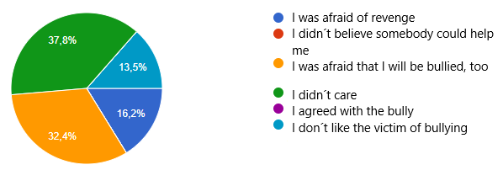

Question 5 37 answers
Which way of bullying exists in your classroom?
 | all | %
Physical attacks, fights | 17 | 45,9
Nonsensical commands | 4 | 10,8
Mockery, calling names | 21 | 56,8
Intimidation, threats | 6 | 16,2
Taking, hiding possession | 15 | 40,5
Damaging possession | 5 | 13,5
Origin, appearance humiliation | 7 | 18,9
Sexual harassment | 2 | 5,4
maltreatment | 1 | 2,7
Food, money, service enforcement | 4 | 10,8
Group exclusion | 9 | 24,3

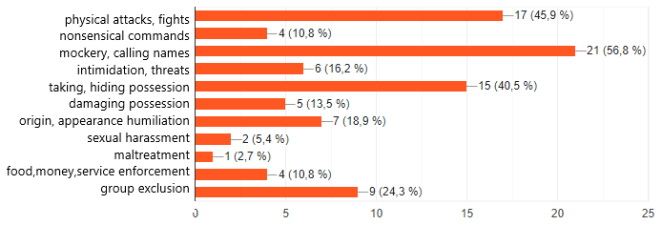

Question 6 37 answers
Which way of cyberbullying exists in your school?

 | all | %
Sending SMS, MMS, phonecalls | 4 | 10,8
Recording and publishing offensive and mocking videos or photos | 13 | 35,1
Defamation on social networks | 10 | 27
Stalking on social networks | 4 | 10,8
Forming enemy group against somebody | 9 | 24,3
Password stealing, misusing of account | 1 | 2,7
Group exclusion, ignorance | 12 | 32,4

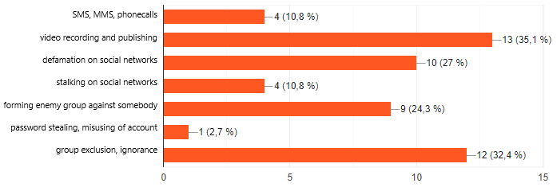

Question 7 37 answers
The bullying is mostly found in:
 | all | %
Classroom during lesson | 1 | 2,7
Classroom during breaks | 12 | 32,4
Other school places - (hall, toilets, changing rooms) | 6 | 16,2
School area during breaks - outside | 7 | 18,9
School area before and after classes | 10 | 27
Not in school – on a playground, street, other places in village | 34 | 91,9

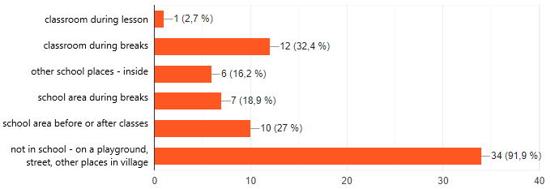

Question 8 53 answers
I think teachers at school .... about bullying:
 | all | %
If they find out, they always take action | 48 | 90,6
They don't take action | 2 | 3,7
They try to conceal it or take it lightly | 1 | 1,8
They mostly don't find out about bullying | 2 | 3,7
They don't know about bullying at school at all | 0 | 0

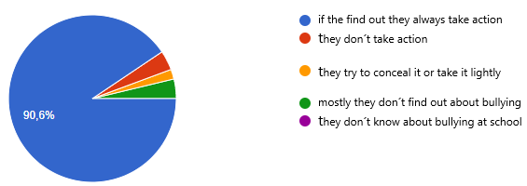

Question 9 53 answers
I want an aggressor to be punished with/by:
 | all | %
Public admonition | 30 | 56,6
Reduced marks of behaviour | 28 | 52,8
Notice to parents and conversation with them | 33 | 62,3
Prosecution by Police | 15 | 28,3
No punishment | 1 | 1,9
School detention | 1 | 1,9
Other (public apology etc.) | 1 | 1,9

