Rozwijanie komunikacji
i integracja zespołów
Andrzejki w klasach I-III

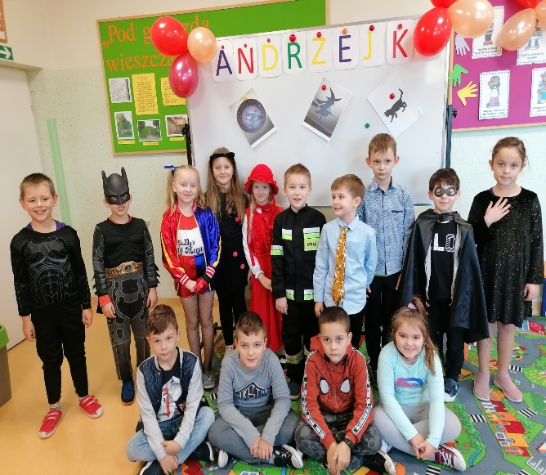
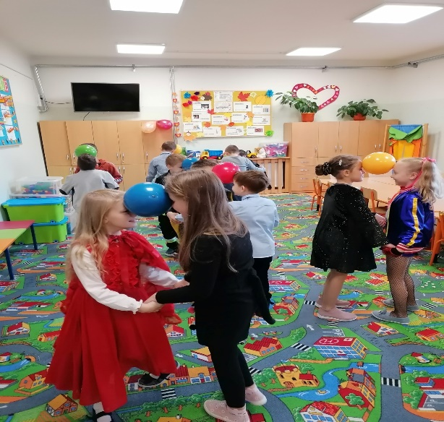

https://spborowa.edupage.org/news/#news-2336

Dbanie o kondycję i aktywność fizyczną
„Sportowe życie to długie życie”

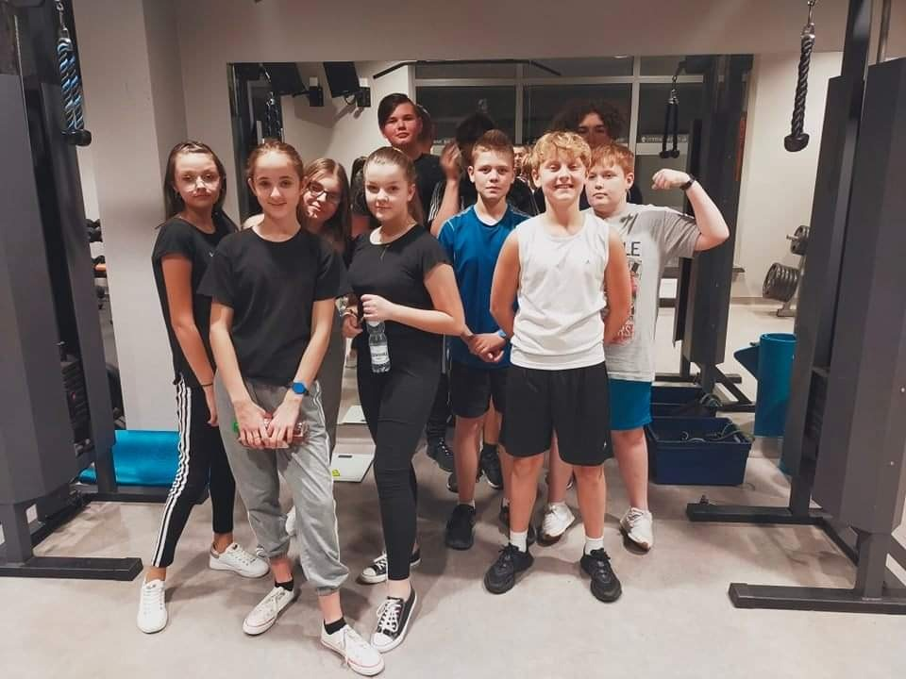
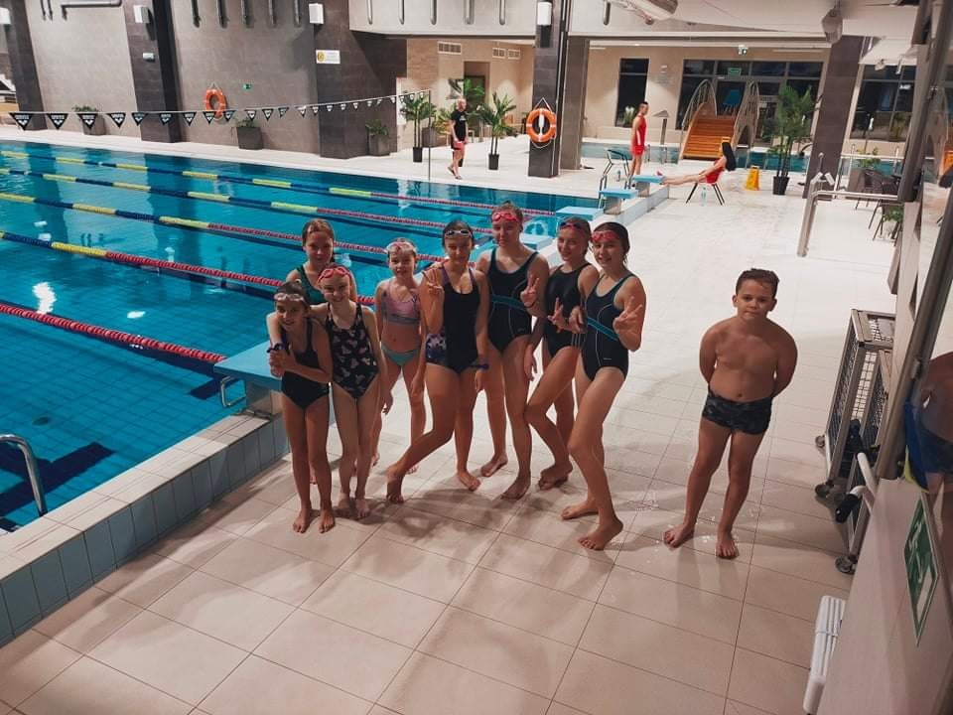

https://spborowa.edupage.org/news/

Dbanie o przyjazny klimat w szkole
Międzynarodowy Dzień Pluszowego Misia

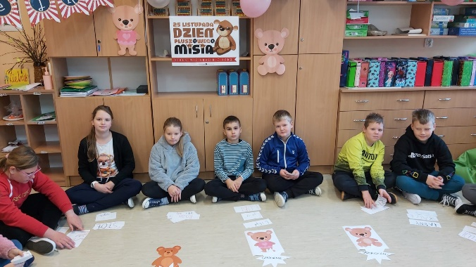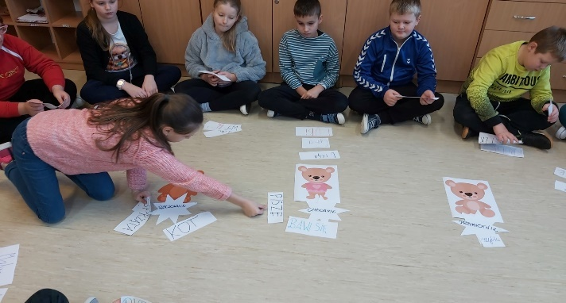

https://spborowa.edupage.org/news/#photos:album:1620

Integracja grupy
Dzień pluszowego Misia w oddziałach przedszkolnych

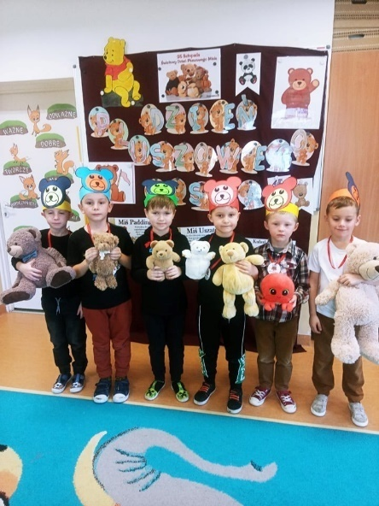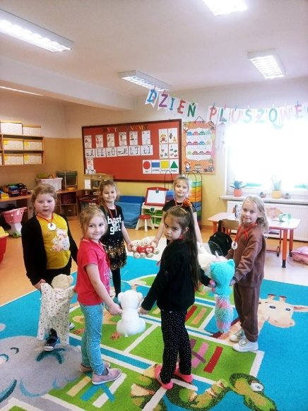

https://spborowa.edupage.org/news/#photos:album:1617
Kształtowanie hierarchii systemu wartości
Dzień Tolerancji i życzliwości

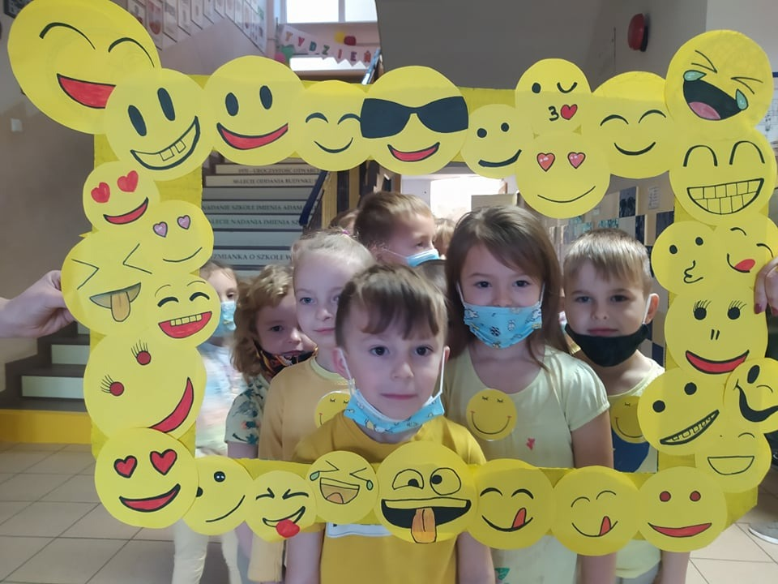
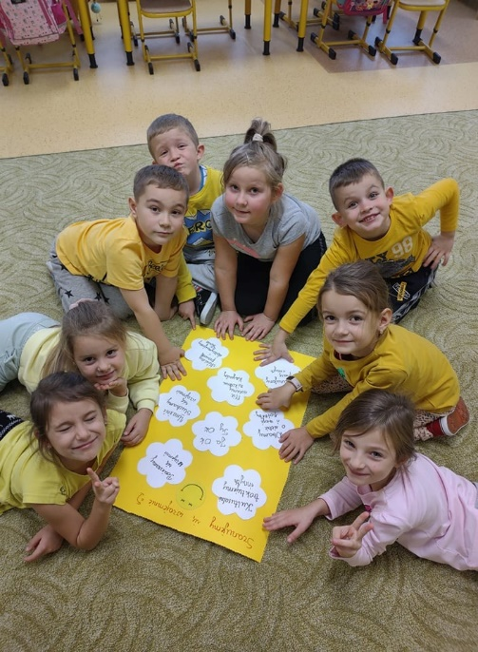

https://spborowa.edupage.org/news/#photos:album:1616
Dbanie o właściwy stosunek do kolegów
i koleżanek.
Rozumiem, szanuję, akceptuję.

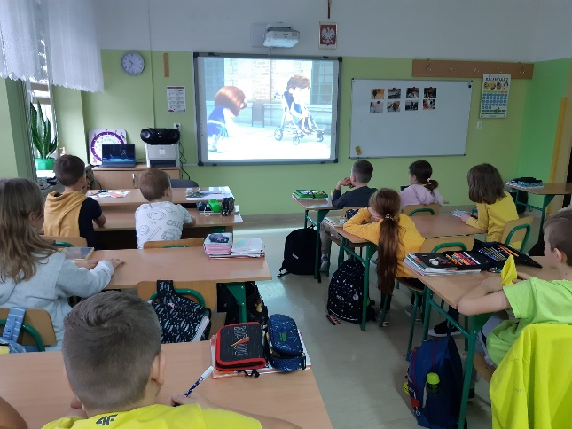
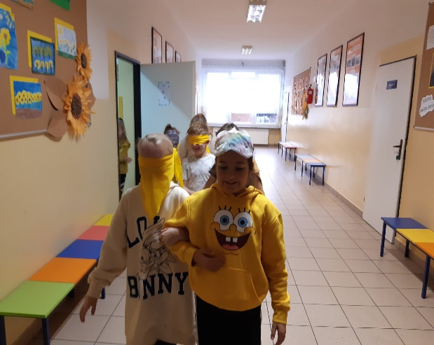

https://spborowa.edupage.org/news/#photos:album:1615
Integracja grupy
Dzień Jeża w oddziałach przedszkolnych

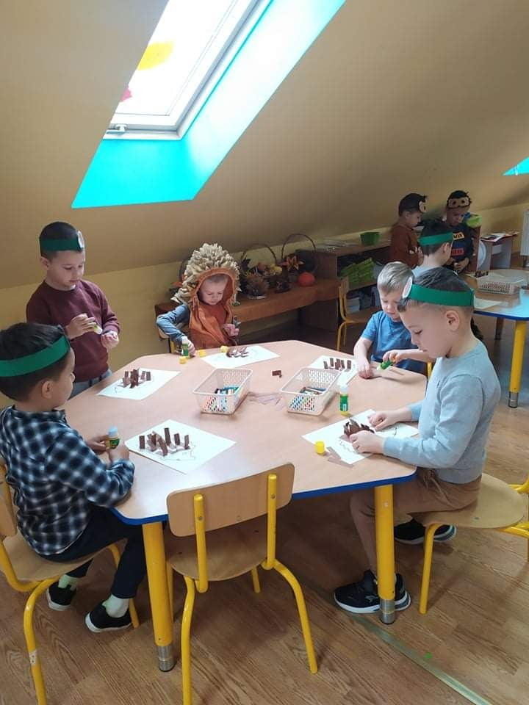
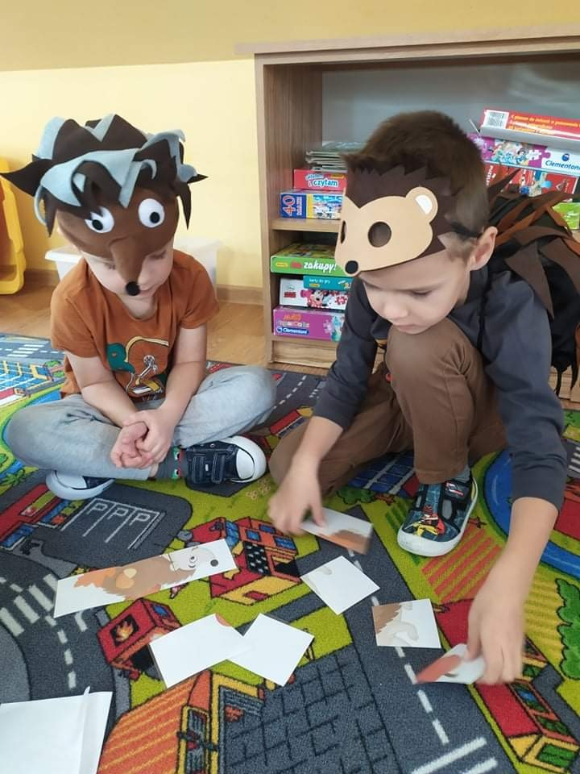
https://spborowa.edupage.org/news/#photos:album:1614

Wolontariat- kształtowanie postaw prospołecznych
Warto pomagać innym

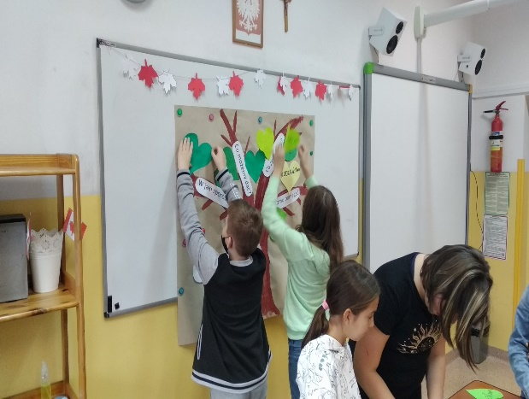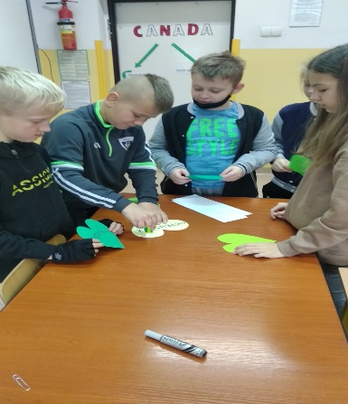

https://spborowa.edupage.org/news/#photos:album:1613

Dbanie o wrażliwość i kulturę
Mobilna Filharmonia w oddziałach przedszkolnych

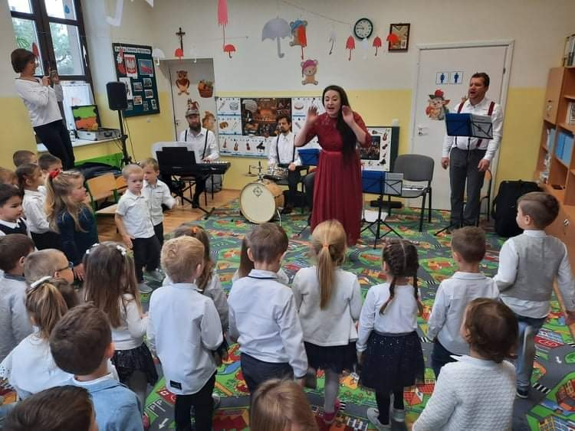

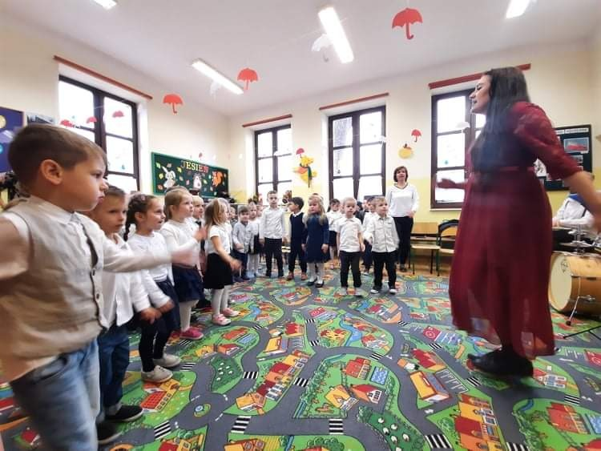

https://spborowa.edupage.org/news/#photos:album:1612
Rozwijanie poczucia własnej wartości
Sukces Izabeli Miłoś- „ Zburzmy mur niezgody-mediacją”.

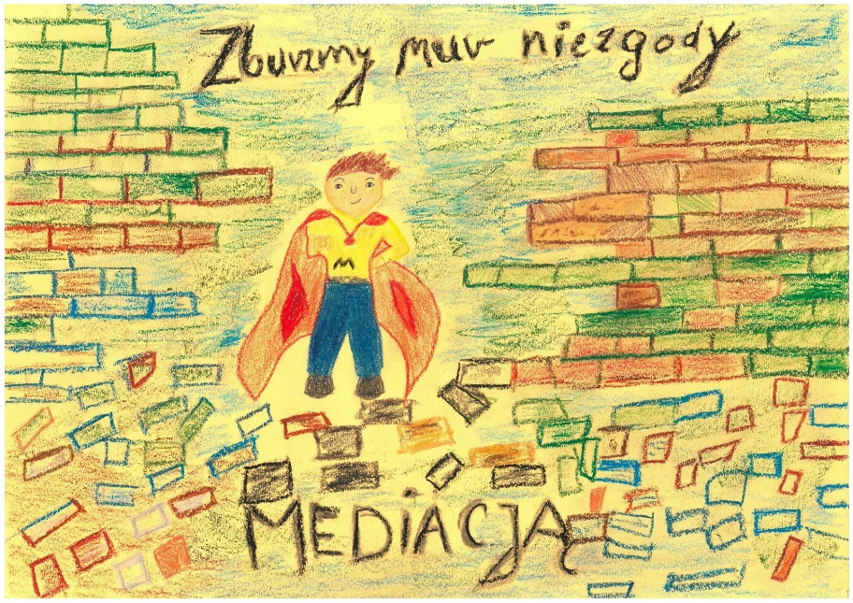

https://spborowa.edupage.org/news/#photos:album:1607
Integracja zespołów klasowych
Przedszkolaki w kinie

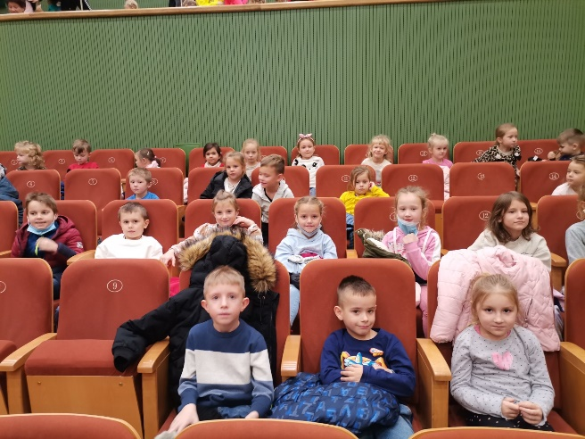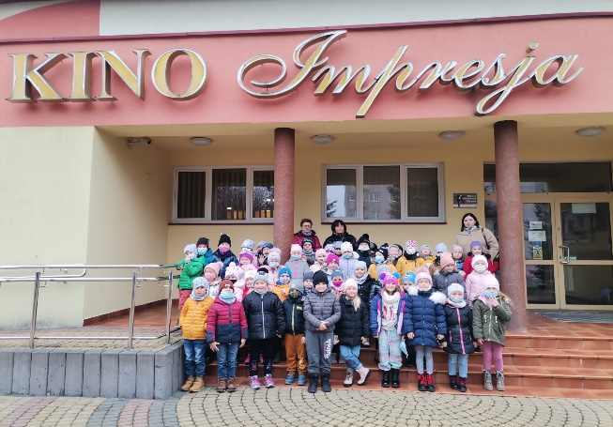

https://spborowa.edupage.org/news/#photos:album:1608
Kształtowanie postaw hierarchii systemu wartości
Szanujemy się wzajemnie

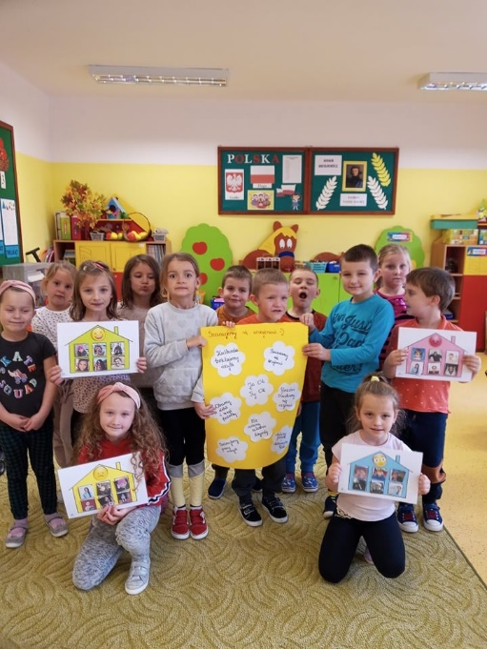
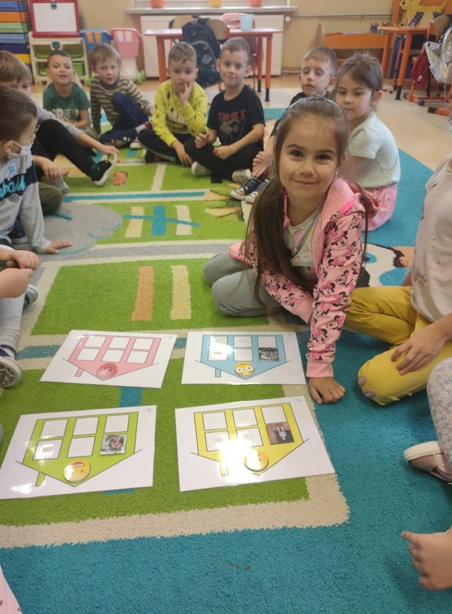

https://spborowa.edupage.org/news/#photos:album:1604
Dbanie o postawę poszanowania tradycji i historii
Gminne obchody Święta Niepodległości

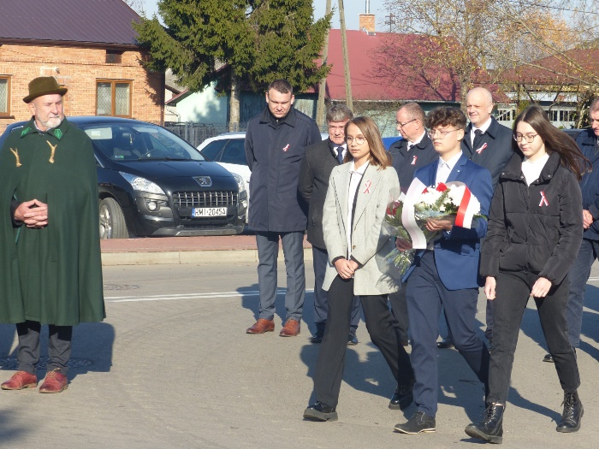
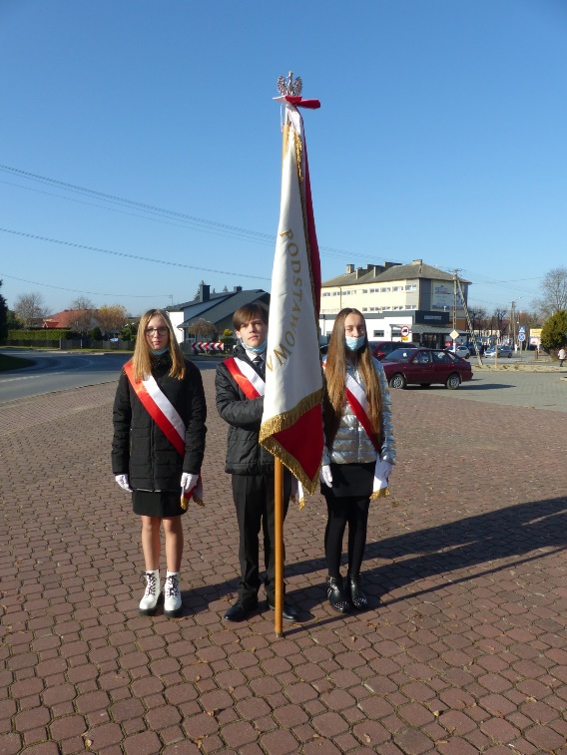

https://spborowa.edupage.org/news/#photos:album:1603

Wskazywanie możliwości spędzanie wolnego czasu
w sposób akceptowalny społecznie
X-obchody międzynarodowego miesiąca bibliotek szkolnych.

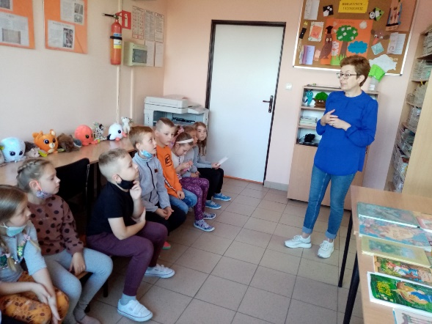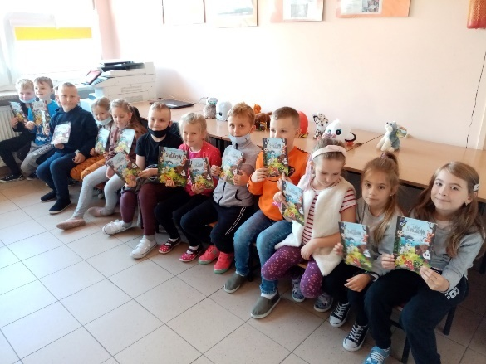

https://spborowa.edupage.org/news/#photos:album:1610
Kształtowanie postaw patriotycznych
Narodowe Święto Niepodległości

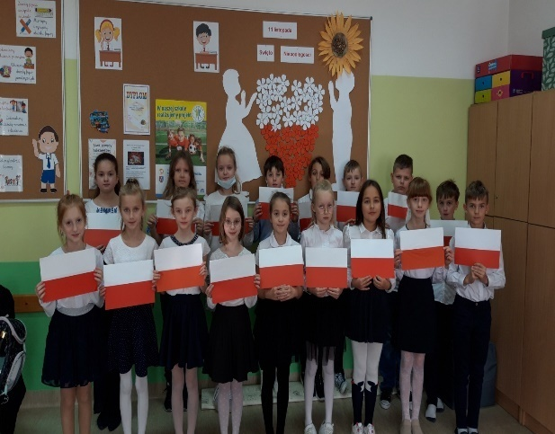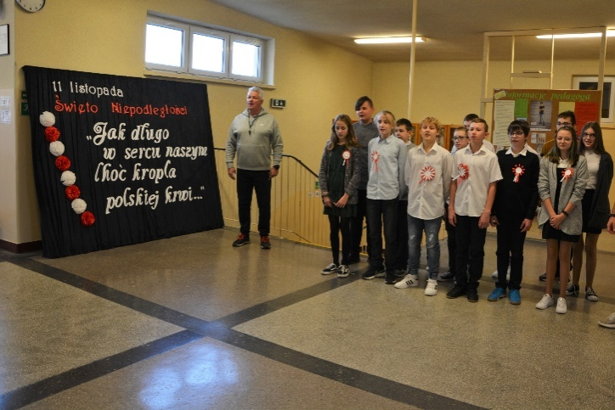
https://spborowa.edupage.org/news/#photos:album:1600

Rozwijanie aktywności fizycznej i ducha walki
Uwaga! Mamy pierwsze miejsce w Polsce!

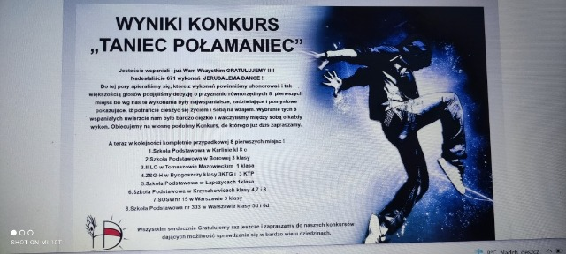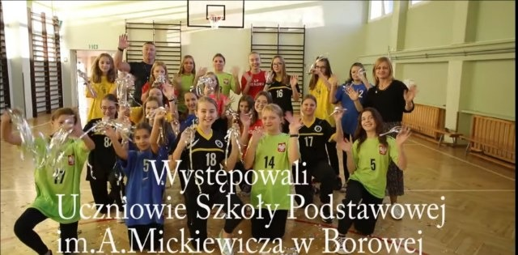

https://spborowa.edupage.org/news/#photos:album:1595

Promowanie postaw prozdrowotnych
Awans do finału wojewódzkiego Unihokeistów

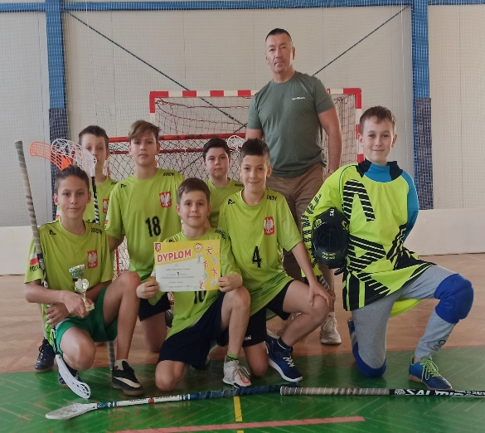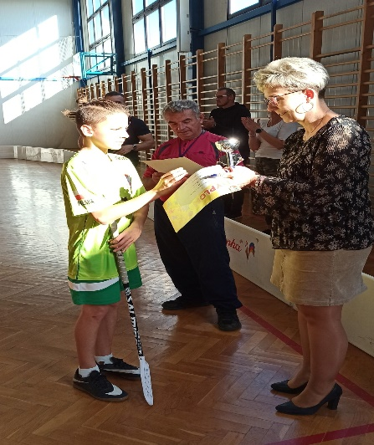

https://spborowa.edupage.org/news/#photos:album:1618
Rozwijanie wartości duchowych
Spacer ze Świętymi

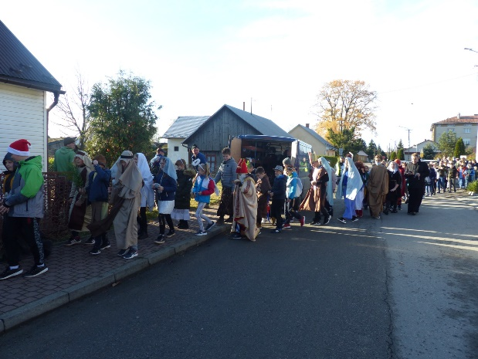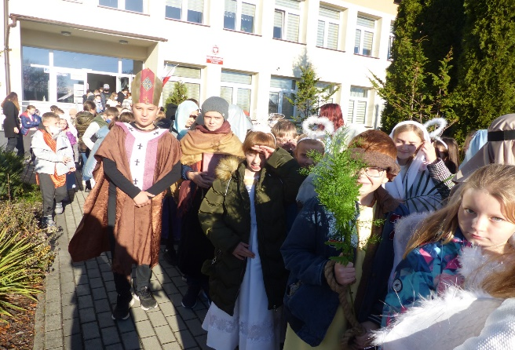

https://spborowa.edupage.org/news/?eqa=d2lkPW5ld3NfTmV3c18xX3AmbmV3c2FyY2hpdmVmPSZvZmZzZXRfbmV3c19OZXdzXzFfcD0yMA%3D%3D#photos:album:1597

Kształtowanie postaw prospołecznych
Różowe skrzyneczki

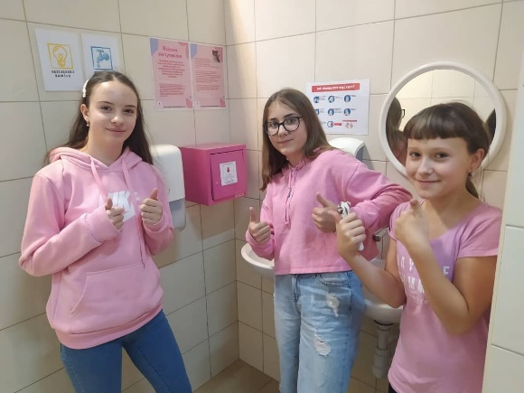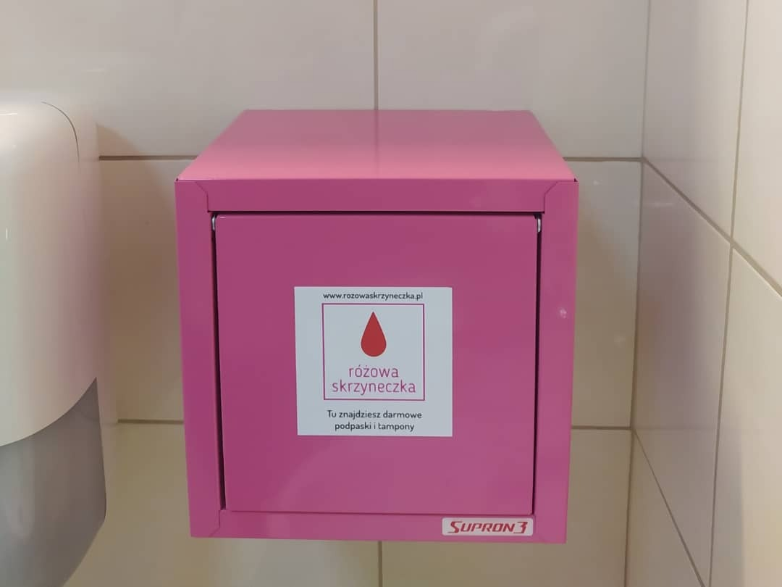

https://spborowa.edupage.org/news/?eqa=d2lkPW5ld3NfTmV3c18xX3AmbmV3c2FyY2hpdmVmPSZvZmZzZXRfbmV3c19OZXdzXzFfcD0yMA%3D%3D#photos:album:1598

Konkurs taniec połamaniec- Jerusalemadance!

Konkurs taniec połamaniec- Jezusalema dance!
https://spborowa.edupage.org/news/?eqa=d2lkPW5ld3NfTmV3c18xX3AmbmV3c2FyY2hpdmVmPSZvZmZzZXRfbmV3c19OZXdzXzFfcD0yMA%3D%3D#

Film z nagraniem dostępny na stronie YouTube.
https://www.youtube.com/watch?v=l_7RoNQZG4I

Budowanie właściwego stosunku do świata
Dzień kultury europejskiej

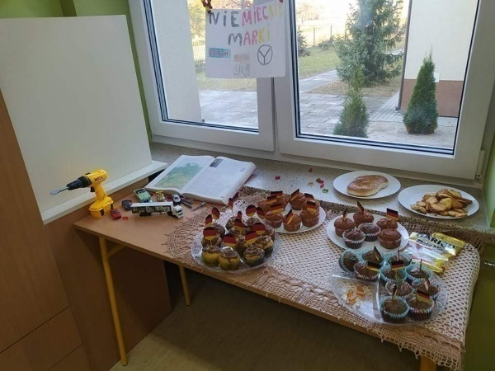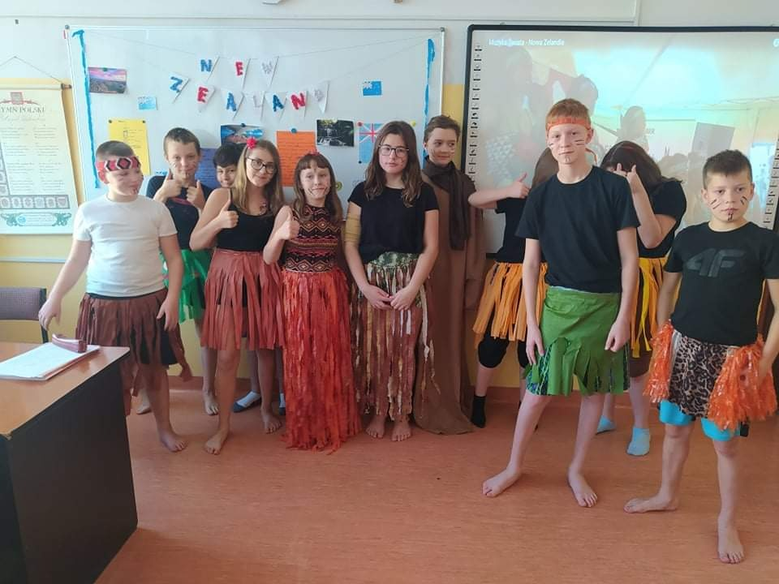
https://spborowa.edupage.org/news/?eqa=d2lkPW5ld3NfTmV3c18xX3AmbmV3c2FyY2hpdmVmPSZvZmZzZXRfbmV3c19OZXdzXzFfcD0yMA%3D%3D#photos:album:1594
Budowanie kreatywności
Dzień Postaci z Bajek

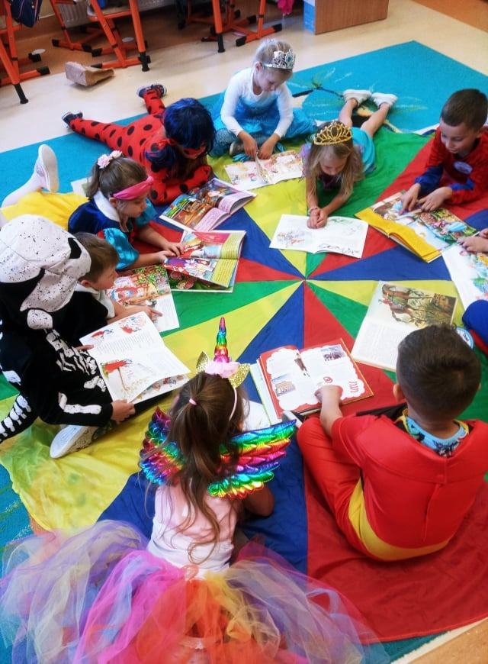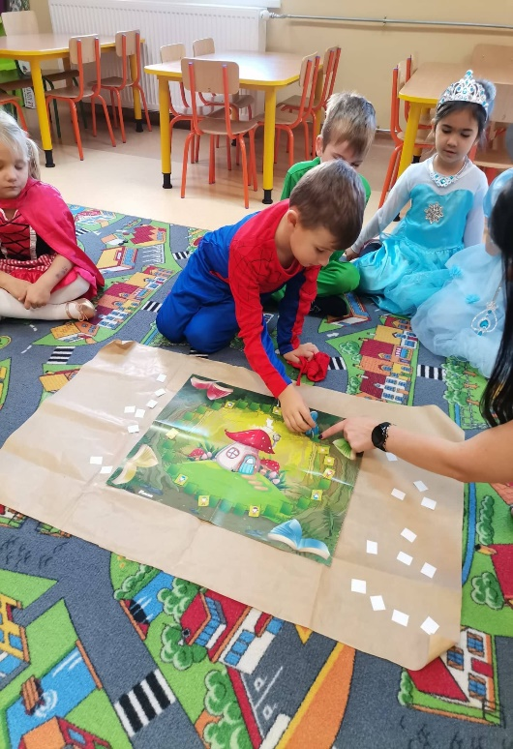

https://spborowa.edupage.org/news/?eqa=d2lkPW5ld3NfTmV3c18xX3AmbmV3c2FyY2hpdmVmPSZvZmZzZXRfbmV3c19OZXdzXzFfcD0yMA%3D%3D#photos:album:1593
Integracja zespołów klasowych
Wyjazd klas I-III do kina

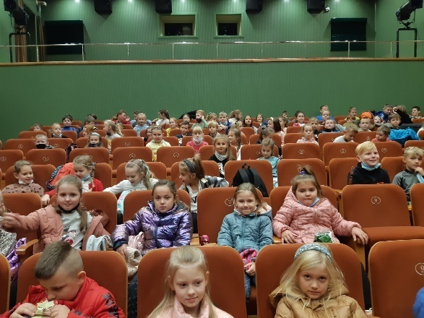
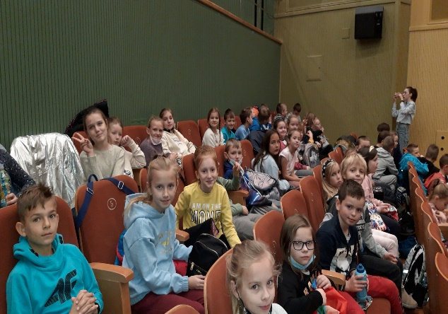
https://spborowa.edupage.org/news/?eqa=d2lkPW5ld3NfTmV3c18xX3AmbmV3c2FyY2hpdmVmPSZvZmZzZXRfbmV3c19OZXdzXzFfcD0yMA%3D%3D#photos:album:1592
Wdrażanie do kultury wysokiej
Wycieczka do teatru

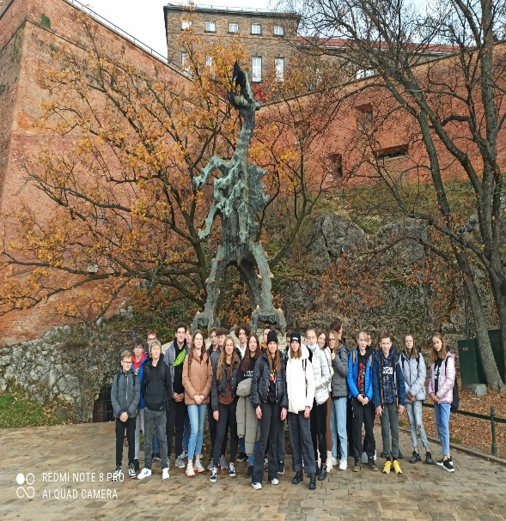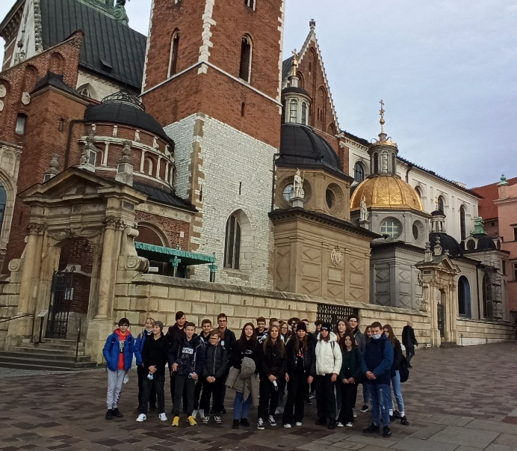
https://spborowa.edupage.org/news/?eqa=d2lkPW5ld3NfTmV3c18xX3AmbmV3c2FyY2hpdmVmPSZvZmZzZXRfbmV3c19OZXdzXzFfcD0yMA%3D%3D#photos:album:1591

Dbanie o bezpieczeństwo uczniów
Spotkania z policjantem

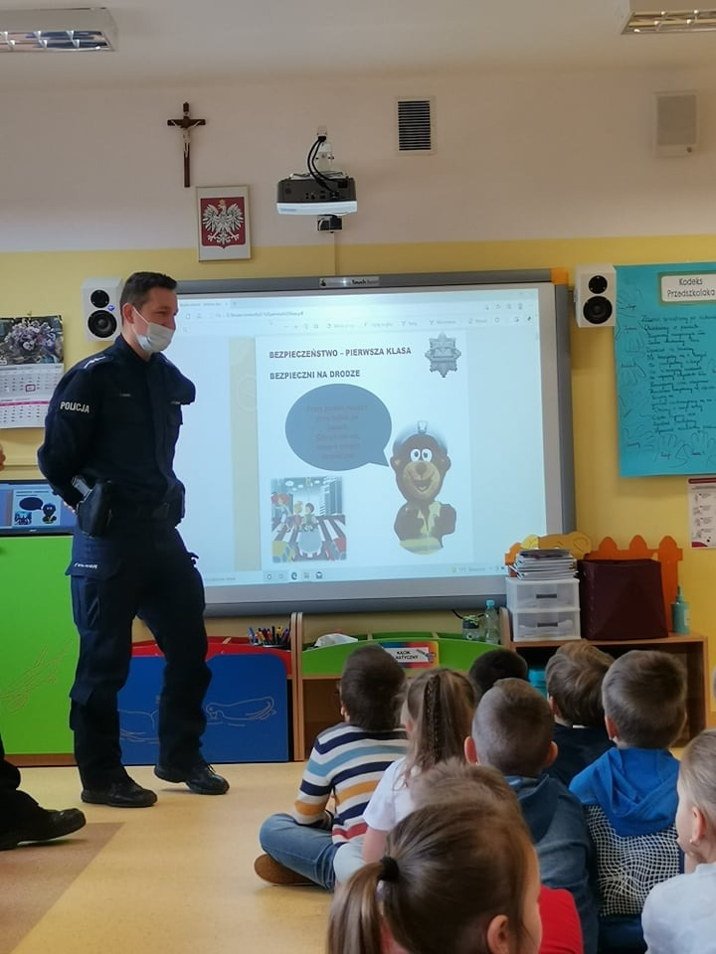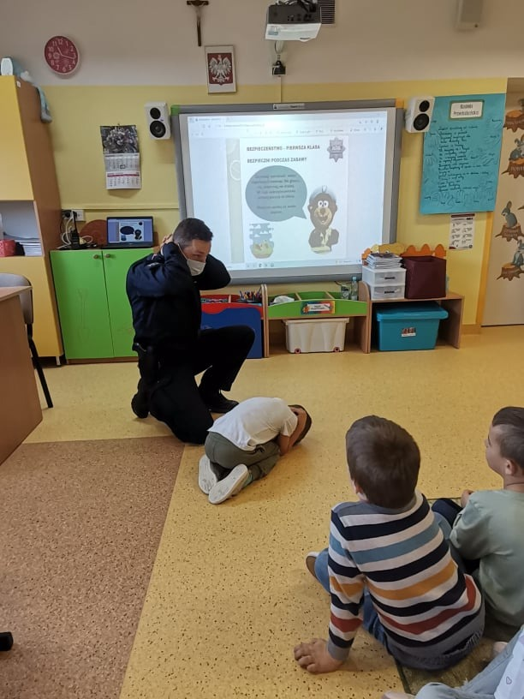
https://spborowa.edupage.org/news/?eqa=d2lkPW5ld3NfTmV3c18xX3AmbmV3c2FyY2hpdmVmPSZvZmZzZXRfbmV3c19OZXdzXzFfcD0yMA%3D%3D#photos:album

Kształtowanie postaw prozdrowotnych
Przedszkolaki kiszą kapustę!

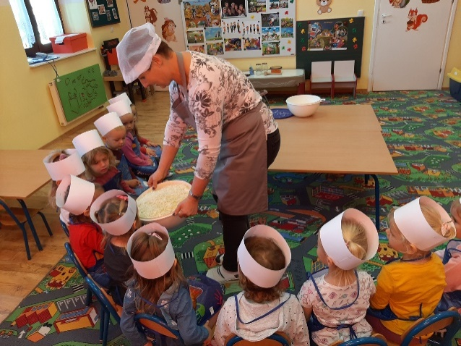

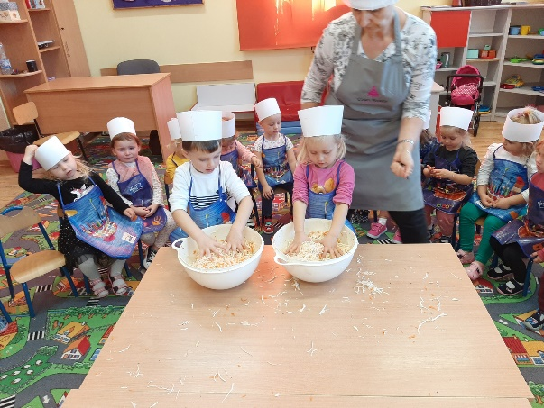

https://spborowa.edupage.org/news/?eqa=d2lkPW5ld3NfTmV3c18xX3AmbmV3c2FyY2hpdmVmPSZvZmZzZXRfbmV3c19OZXdzXzFfcD0yMA%3D%3D#photos:album:1588
Dbamy o ekologię
Obserwacje przyrodnicze w Dolinie Wisłoki

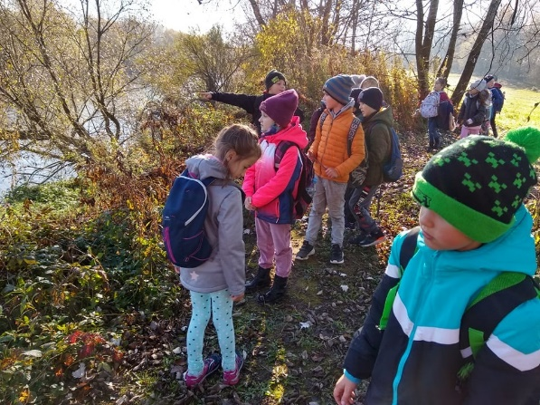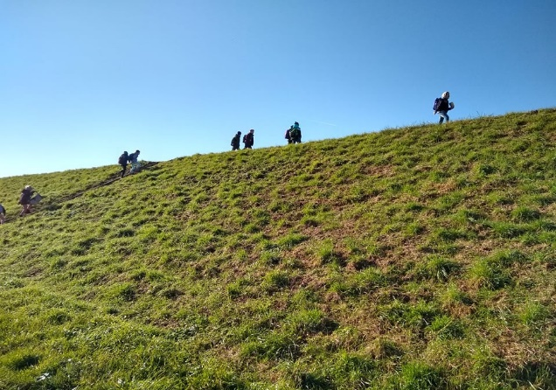
https://spborowa.edupage.org/news/?eqa=d2lkPW5ld3NfTmV3c18xX3AmbmV3c2FyY2hpdmVmPSZvZmZzZXRfbmV3c19OZXdzXzFfcD0yMA%3D%3D#photos:album:1584
Rozwijanie harmonii psychicznej
Nasz udział w akcji czytelniczej „Przerwa na czytanie”.

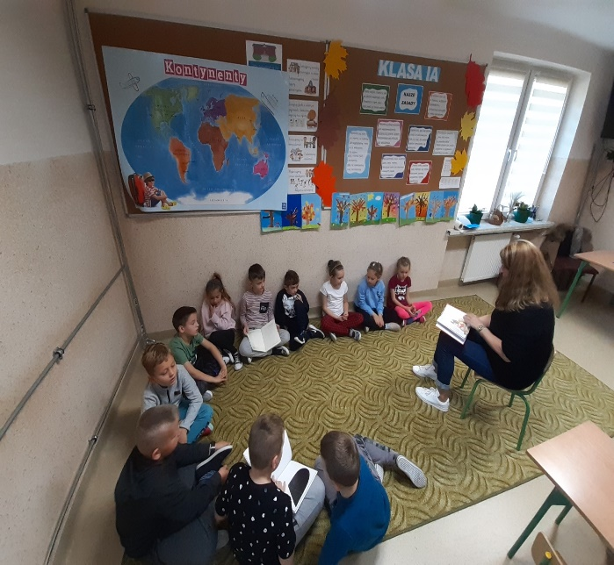
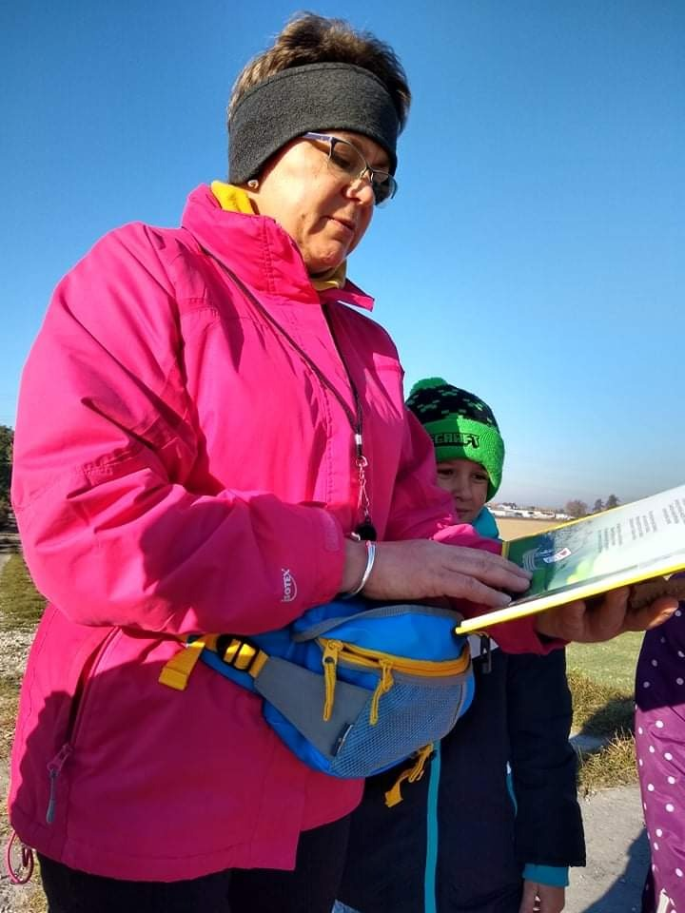
https://spborowa.edupage.org/news/?eqa=d2lkPW5ld3NfTmV3c18xX3AmbmV3c2FyY2hpdmVmPSZvZmZzZXRfbmV3c19OZXdzXzFfcD0yMA%3D%3D#photos:album:1583
Kształtowanie postaw sprzyjających rozwijaniu własnego potencjału
CodeWeek- europejski tydzień kodowania

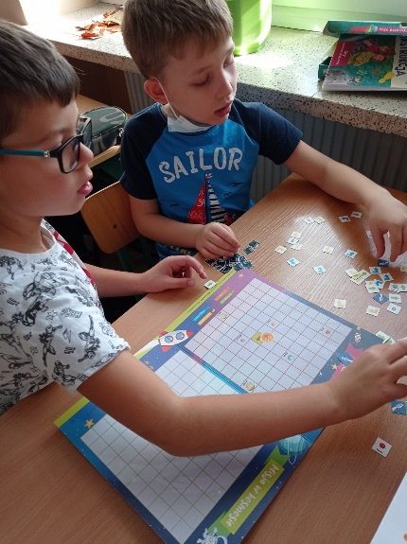
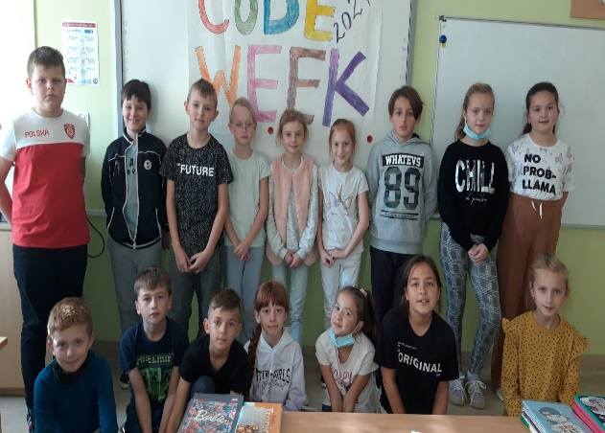

https://spborowa.edupage.org/news/?eqa=d2lkPW5ld3NfTmV3c18xX3AmbmV3c2FyY2hpdmVmPSZvZmZzZXRfbmV3c19OZXdzXzFfcD0yMA%3D%3D#photos:album:1587

