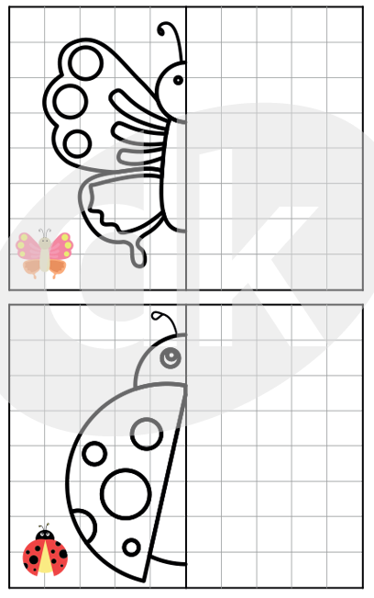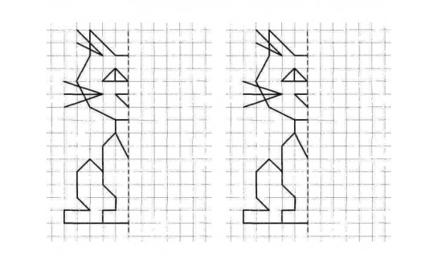

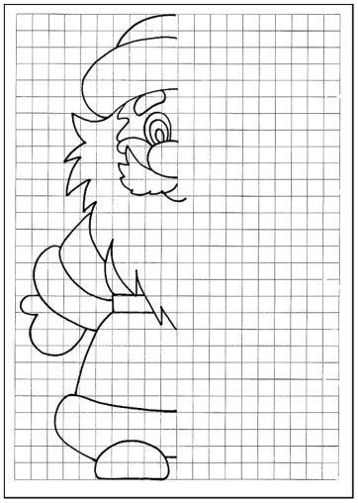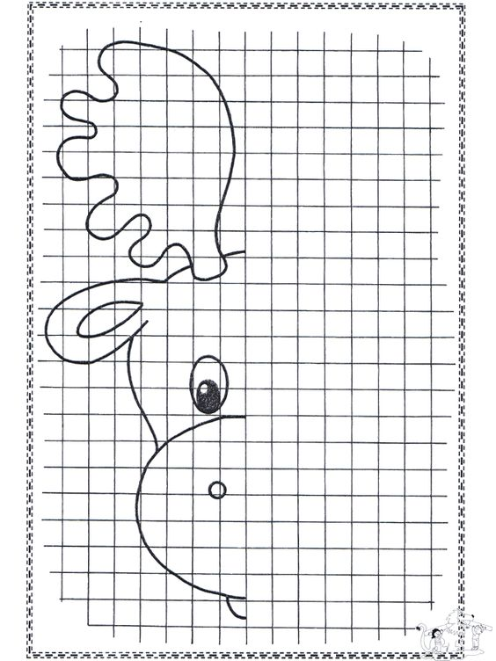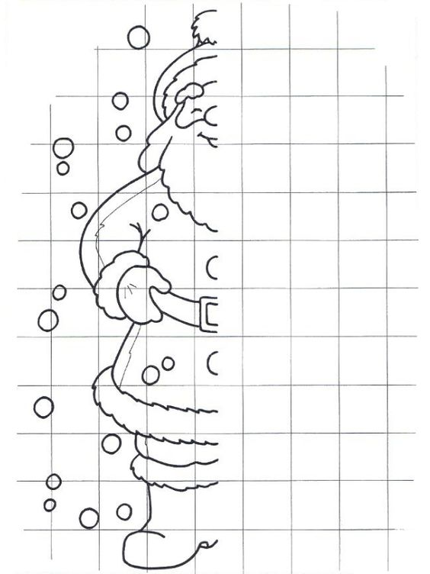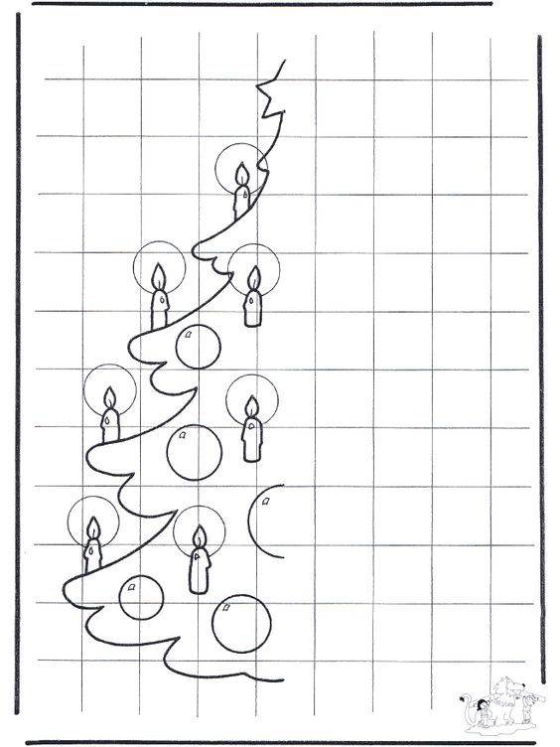

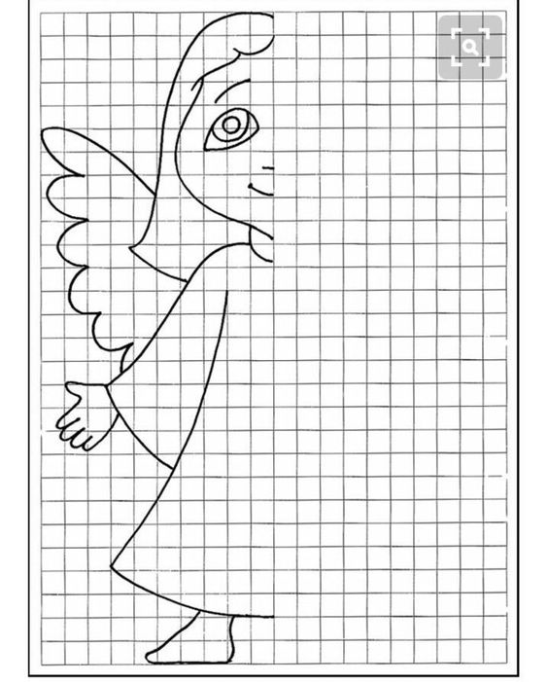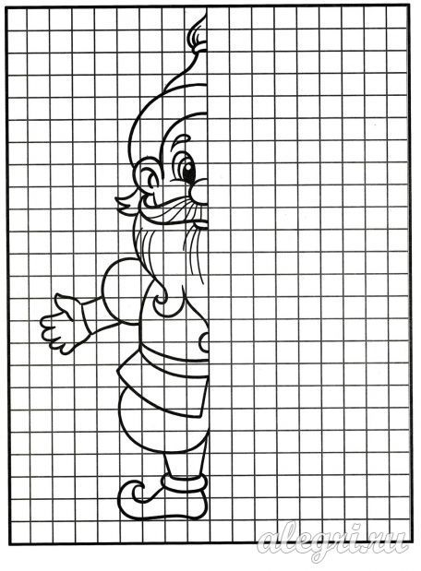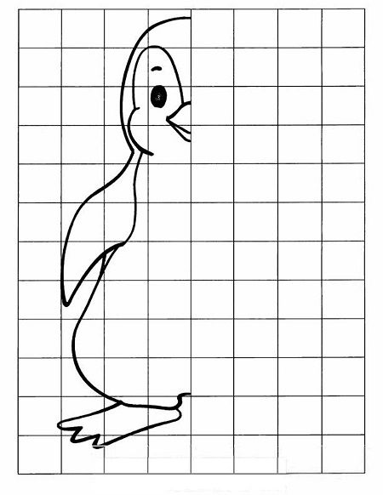
ZDROJE
https://www.google.com/search?q=osov%C3%A1+s%C3%BAmernos%C5%A5+pracovn%C3%BD+list&tbm=isch&source=iu&ictx=1&fir=bV1PKazEWunVWM%252C8oGDwF0BlorJM%252C_&vet=1&usg=AI4_kTRDGRb8svNHhKHhlIfKvpi2boEkQ&sa=X&ved=2ahUKEwjeucOv0YztAhWpxYUKHZ4dDZ8Q9QF6BAgCEDw&biw=1366&bih=657#imgrc=bV1PKazEWunVWM
https://www.datakabinet.sk/sk/Vzdelavacie-materialy/ISCED-1/3-rocnik-ZS/Matematika/Geometria/Rysovanie-rovinnych-utvarov-v-stvorcovej-sieti/Osova-sumernost.html
https://sk.pinterest.com/pin/681028774880545389/
https://sk.pinterest.com/pin/387309636705708583/
https://sk.pinterest.com/pin/311944711691546922/
https://sk.pinterest.com/pin/555209460316233925/
https://sk.pinterest.com/pin/564779609525708968/
https://sk.pinterest.com/weronicka09/dokres%C4%BEovanie-sp%C3%A1janie/

